

Certificate of Employment

To: 26th November 2024
U.S. Visa Officer, U.S. Embassy - London
33 Nine Elms Lane
London
SW11 7US

To whom it may concern,

This is to certify that Ms Peifan Lyu, DoB: 29/02/1996, Nationality: Chinese, Passport Number: E73143123, has been employed with Synergy Solutions International Limited since 18th January 2024 and is currently working as a Business Analyst. Ms Peifan Lyu is a full-time employee and receives an annual salary of £40,000.00. She has demonstrated excellent performance and commitment to her role during her time with our company.

Ms Peifan Lyu will have a tour to the US from 23rd December 2024 to 2nd January 2025 and she will be due back at our company to resume employment on 6th January 2025.

This certificate is being issued upon Ms Peifan Lyu’s request for the purpose of applying for a U.S. Tourism Visa. We hereby guarantee that she will abide by all the laws and regulations during her stay abroad. All travel expenses will be borne by her. We also guarantee that she will be back to UK on schedule and will continue to work for our company on time.

If you require further information, please do not hesitate to contact us. Your kind approval of this application will be highly appreciated. Thank you!

Yours sincerely,
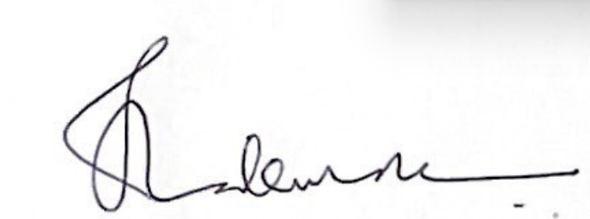

Shiv Kumar Thakur


Director

